**Exercise 9: Creating a Spring Boot Application**

Scenario:

You need to create a Spring Boot application for the library management system to simplify configuration and deployment.

**1. Project Setup**

**1.1 Creating a Spring Boot Project**

The Spring Boot project was created using Spring Initializr with the following specifications:

* **Project Name**: LibraryManagement

**1.2 Adding Dependencies**

The pom.xml file was configured to include the necessary dependencies:

* spring-boot-starter-web: For building web applications, including RESTful services.
* spring-boot-starter-data-jpa: For JPA (Java Persistence API) integration.
* h2: In-memory database for testing and development.

**2. Application Configuration**

**2.1 Application Properties**

The application.properties file was configured to set up the H2 database and JPA. This configuration enables the H2 console for viewing the database and sets up the JPA for managing database operations.

**3. Entity and Repository Setup**

**3.1 Book Entity**

The Book entity was created to represent books in the library. This class is annotated with @Entity to define it as a JPA entity

**3.2 BookRepository Interface**

The BookRepository interface was created by extending JpaRepository to provide CRUD operations for Book entities:

**4. REST Controller**

**4.1 BookController**

The BookController class was implemented to handle RESTful API requests for Book entities. This class includes the following endpoints:

* GET /books: Retrieve all books.
* GET /books/{id}: Retrieve a book by ID.
* POST /books: Create a new book.
* PUT /books/{id}: Update a book.
* DELETE /books/{id}: Delete a book by ID.

### ****5. Running the Application****

The Spring Boot application can be run using the main method in LibraryManagementApplication class. The application will start on the default port, and you can test the REST endpoints using tools like Postman or curl.

OUTPUT:  
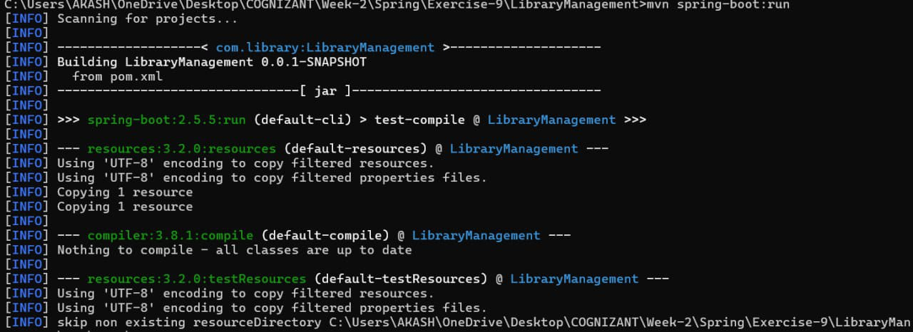

**FLOWCHART of the program :**

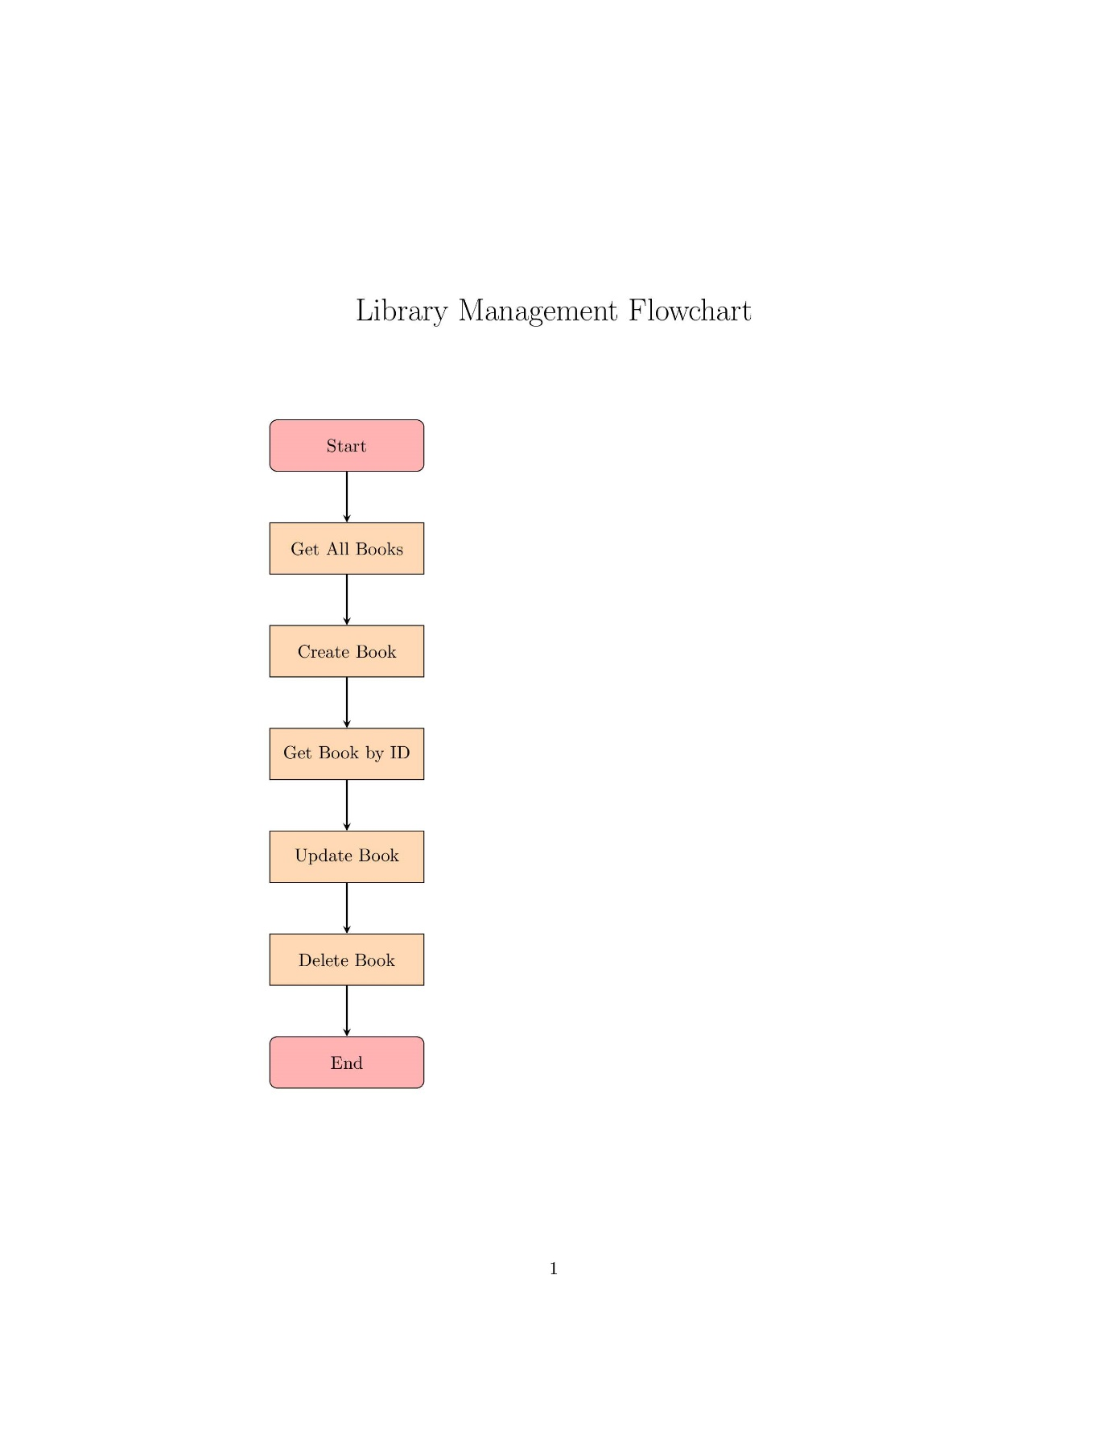

The flowchart for the Library Management System illustrates the following process:

1. **Start**: The flowchart begins with starting the application.
2. **Get All Books**: The system retrieves all books using GET /books.
3. **Create Book**: A new book is created using POST /books.
4. **Get Book by ID**: The system retrieves a specific book using GET /books/{id}.
5. **Update Book**: An existing book is updated using PUT /books/{id}.
6. **Delete Book**: A book is deleted using DELETE /books/{id}.
7. **End**: The flow ends.

**CLASS DIAGRAM:**

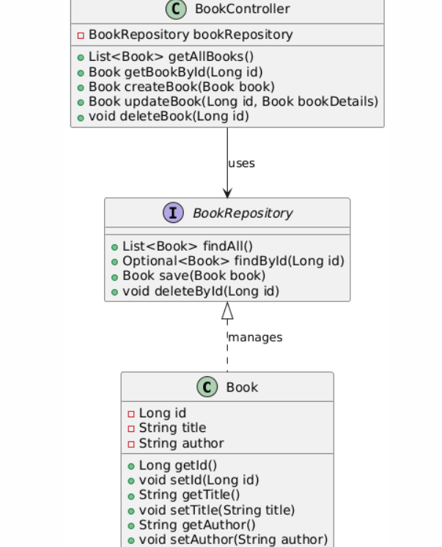

The class diagram for the Library Management System includes the following components:

* **Book Entity**: Represents a book with attributes such as id, title, and author.
* **BookRepository Interface**: Manages Book entities with methods for CRUD operations.
* **BookController**: Handles HTTP requests related to Book entities by interacting with BookRepository.

The relationships are:

* BookController uses BookRepository.
* BookRepository manages Book entities.